Preparation:

Hardware:

-ST-link/v2

-RLY-8 Relay Controller

-jumper wires(F/M)

-USB cable

Software:

-Firmware hex file

-st-link usb driver

-stm32 st-link utility

Connection diagram:

-remove the case of the relay controller

-get connected the SWDIO,SWCLK,GND and 3.3v.

For JTAG interface:   
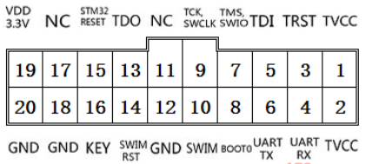

Another version of ST-LINK, Pins are labeled on the device.

ST-LINK - relay controller

SWDIO - SWDIO

SWCLK - SWCLK

GND - GND

3.3v - 3.3v

图一

Configuration:

1. Install the driver

Click Next

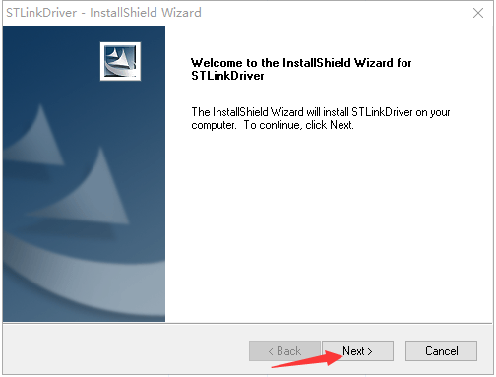

Click Next



Click install

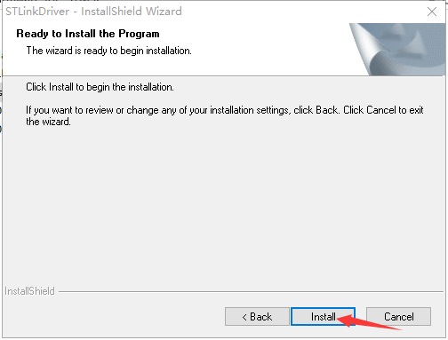

After finishing the driver install, connect the ST-link to your PC, you can find the STM32 ST-link in your device manager.

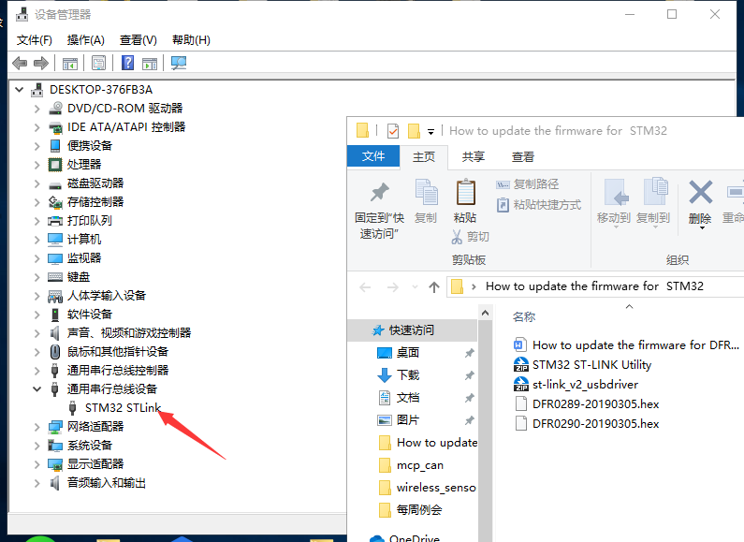

1. Open stm32 st-link utility

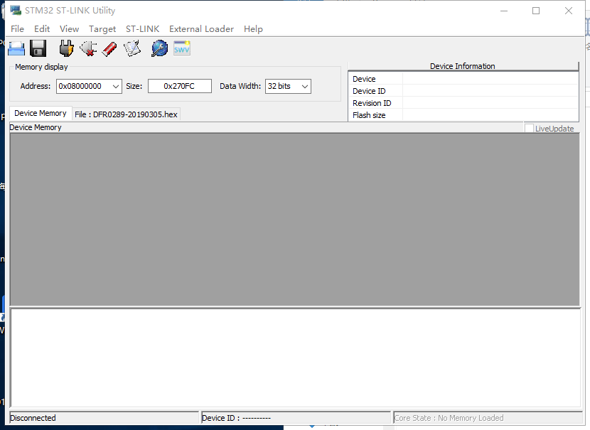

File - open

Open the hex file, in this case, we use dfr-289.

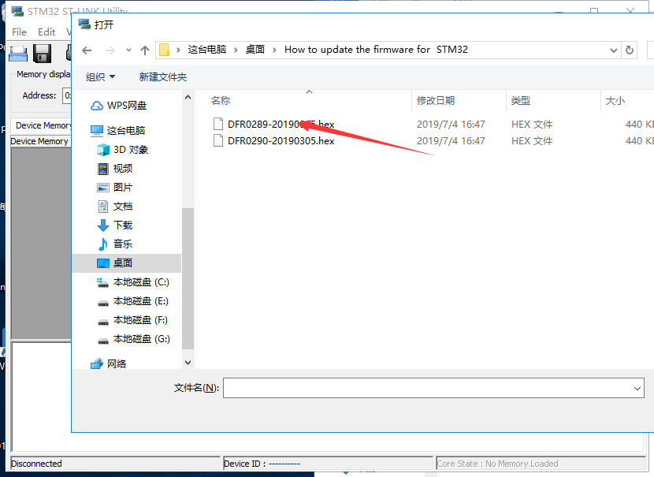

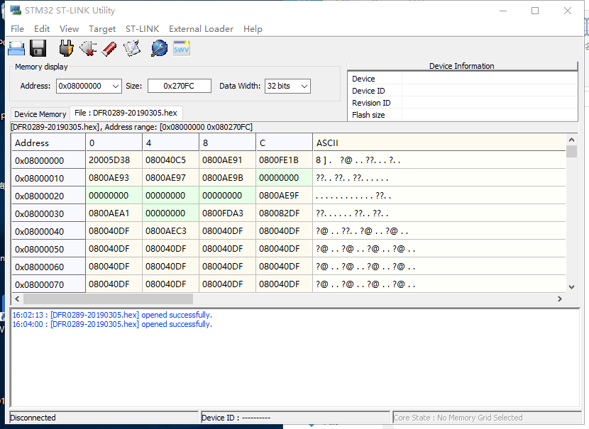

Target-settings

If the jumper wire is well-connected, it will show the target info. The relay controller board should be get powered either via USB or power adapter.

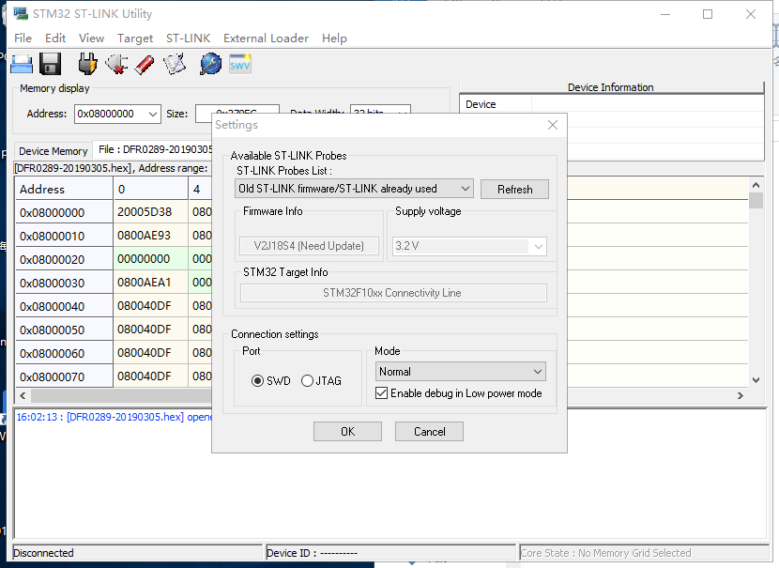

Click the third icon and connect to target

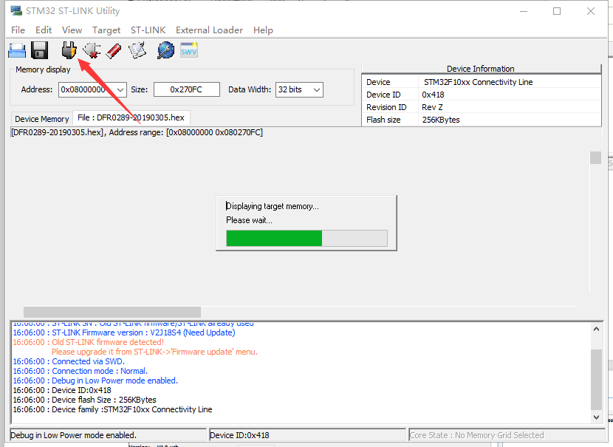

Click the sixth icon, program and verify

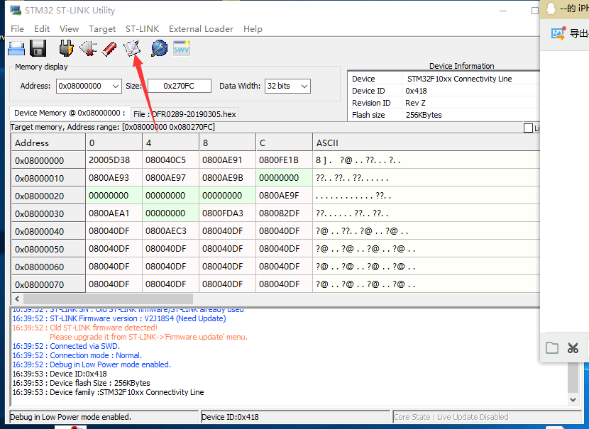

Click start to start burn the firmware

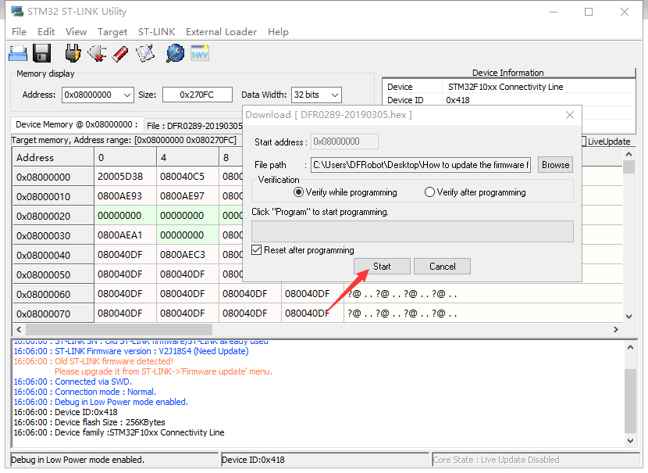

Successfully

